CONCEPT PAPER: UN Support to the MCC process
Background
Kosovo was accepted as an eligible candidate for an MCC Compact on December 2015. Institutions of Kosovo attempted to apply to the MCC threshold in 2012, marking their readiness to start measuring necessary indicators which would reflect its social, economic and political progress. Kosovo's 2012 scorecard of FYI showed only three passing indicators, and then seven indicators in 2013. In 2015, Kosovo passed on 13 indicators thanks to the invested efforts from all involved. The Presidency of Kosovo has approached the UN Kosovo Team (UNKT-equivalent UN Country Team) to request support in providing updated, relevant and available UN data on the MCC. This includes the data made available for the first time in Kosovo through the flagship UNICEF survey, the Multiple Indicator Cluster Survey (MICS) conducted by UNICEF and Kosovo Agency of Statistics (KAS) in 2013-2014, WHO reporting on Health Expenditures, and UNDP data on corruption, all of which enabled Kosovo to report and pass for the first time in a number of indicators in the area ‘Investing in People’ and ‘Ruling Justly’. While there was visible progress, the quality of available data in some areas still remains a challenge. To address this challenge, UN agencies in Kosovo will pursue a twofold approach:
- Identify possibilities to measure indicators which have never been on the radar for Kosovo institutions. i.e.: Land Rights and Access; Trade Policies; and Control of Corruption;
- Continue to keep track of socio-economic and political progress in Kosovo where methodology exists, measuring data at least once.
These will request continuous attention in line with the MCC support.
The UN agencies in Kosovo recognize that more than 15 years after conflict, Kosovo is still working to build a solid foundational platform for human development, socio-economic stability and democratic transparency of institutions. As such they have undertaken the task to collect and compile data from the UN and other independent institutions into one unified source of information on the progress of MDGs, including the MCC indicators. This information package facilitates sharing of most recent developmental progress with donors and partners and also provides direct links with the UN agencies involved in the research. This file will be updated on an annual basis, as data becomes available.
Data shows that Kosovars still struggle with high levels of poverty, environmental degradation, inter-ethnic tensions and deficient social inclusion. Analysis conducted for the UNICEF joint programme of collaboration with Institutions of Kosovo 2016-2020, as well as UN’s Kosovo Common Development Plan (CDP) 2016- 2020 shows ongoing and contextual challenges, in the economic, environmental, health, political life and rule of law institutions. For example:
- Kosovo has the highest poverty rate in Europe with 10.2% extreme poverty (1.25$ per day) and 29.7% relative poverty (2$ per day); the overall unemployment rate is 35% with youth unemployment at 45%;
- In the 2012 Human Development Report, the HDI in Kosovo reached 0.714 placing Kosovo in the group of high-ranking HDI members. However, in comparison with the Western Balkans and the European Union (EU), Kosovo is still ranked lowest.
- Average per capita real GDP growth rate between 2009 and 2014 was 1.8 per year, not sufficient enough to translate into significant changes in the key development indicators.
- Kosovo has the lowest employment rate for women in Europe at 12.9% compared with 44% for men, while the unemployment rate is 38.8% for women and 26.9% for men.
- Kosovo invests 4.9% of its budget in education, which is higher compared to previous years but lower that the 6% average among high-income countries. Thus, the quality of education is still inadequate and is not tailored to current market demands;
- Air, water and land pollution are factors that negatively affect the health of the population. Poor administration of water systems and land is the main problem with 28 contaminated sites and 74-90% polluted wells.
- 78 percent of the household population in Kosovo are using an improved sanitation facility which is not shared
- Around 50% of Kosovars have the perception of large-scale corruption in healthcare, customs and other public institutions; approximately 10% of the adult population reports having either directly or indirectly been exposed to annual bribery experiences with a public official. Businesses also claim to have experienced bribery: 11% of those who have contacts with the public administration claim to pay at least one bribe annually and many mention doing so with considerable regularity.
Regardless, the current context in Kosovo provides many opportunities to address factors that erode good governance and basic living conditions with the available services. The progress that Kosovo has achieved in the last decade or so, proves that these 1.8 million young and resilient people, when matched with the right opportunities, are a formula for success towards a better future. MCC’s support to Kosovo is crucial to facilitate the institutional change in the areas of governance and education with a renewed energy, as an "out of reach” process is made a reality for Kosovo.
Opportunities for Kosovo
The current GDP for Kosovo stands at $7.274 billion with GNI per capita at $4.000 (WB data 2014), putting Kosovo in a Low-Middle Income level. The perception among Kosovars is that the greatest share of aid has been channelled into governance and democracy structures, as well as used for long term infrastructure rehabilitation. This is perceived to be done at the expense of highly needed support for qualitative public services such as education – which received only 5-6% of donor money in 2002 and 2004 – the health sector, police, justice department and capacity development for public servants.
The health, education and labour sectors, including social services (e.g. social assistance, health coverage and life-long learning), remain underfunded by the government with not much prospect of a change soon.
In the time since the December 2015 announcement of eligibility for MCC Compact, Kosovo institutions have been at the forefront of MCC funding realization, beginning with the election of the National Coordinator and the team for experts to lead this process in the next five years. The Ministry of Finance has committed 200,000€ for 2016 to undertake economic constraint analysis, and maintaining the necessary team, utilizing new and existing tools and mobilize inter-institutional commitments.
UN agencies in Kosovo involved in providing data for the MCC scorecard, specifically UNDP, UNICEF and WHO, responded to the invitation of the President of Kosovo in mid-2015, to provide data on several indicators which were not made available in Kosovo before. In this respect, the UNICEF flagship survey the MICS implemented for the first time in Kosovo, availed data that was for the first time collected for Kosovo, thereby providing for the first time data to populate the MCC scorecard. These were also MCC specific indicators. Of the eight indicators under "Economic Freedom" five remained above passing threshold. All six indicators under "Investing in People" were below the threshold in the 2015 Scorecard. WHO provided technical assistance to Kosovo institutions that made it possible to produce data on Health expenditures, UNICEF provided data on Child Health, Education and Immunisation, of which all passed. A number of organizations provided funding for this including Government of Austria, the Government of Luxembourg and UNFPA. Data provided by UNICEF were collected through the MICS survey, one of the largest source of statistically sound and internationally comparable household data sets – inclusive data on adolescents, and children worldwide – a global UN recognised methodology and in line with MCC requirements. For indicators under "Ruling Justly", WB/WGI and UNDP data (also supplemental) showcased the key progress which made eligibility possible- with four out of six passing indicators including the Corruption one. Compared to the 2015 FYI Scorecard, this sector proved 100% passing rates – from two to four.
UNDP, UNICEF, WHO and USAID coordinated actions with relevant stakeholders which supported facilitation of a credible process with the MCC and the US State Department. USAID serves as the key MCC partner since Kosovo has not yet signed the compact. That is why more work is needed during this fiscal year to develop the compact. A steering committee comprised of the team from the Office of the Development Coordinator, UNDP, UNICEF, WHO and other UN entities, will provide sources of qualitative and quantitative data in the areas of UN mandated relevance. UN agencies in Kosovo will continue to build on partnerships that were developed for supporting Kosovo in passing the Compact; logically positioning it to continue to another phase of support.
Paired with more accountable Kosovo institutions, this partnership will enable a positive change in the development of these areas over the next years.
A proposal for UN support
The Board of MCC looks at three legislatively-mandated factors in its evaluation of any candidate country for compact eligibility:
(1) policy performance;
(2) the opportunity to reduce poverty and generate economic growth; and
(3) the availability of MCC funds.
Joint UN priorities as outlined in the UN Common Development Plan 2016-2020 (Governance and Rule of Law; Social Inclusion; and Environment and Health) are closely aligned with the focus of the MCC on policy performance, poverty reduction, and economic growth.
UN agencies in Kosovo have years of experience in infrastructure, social and economic development, solid research capacities and networking, which makes them uniquely placed to share UN knowledge, identify resources, and provide guidance when and as necessary. They have the capacities to continue creating workable linkages between the Kosovo NDS, the respective agency joint programmes with the institutions of Kosovo, the CDP, the local policies and mid-term strategic plans such as the MTEF 2016- 2018.
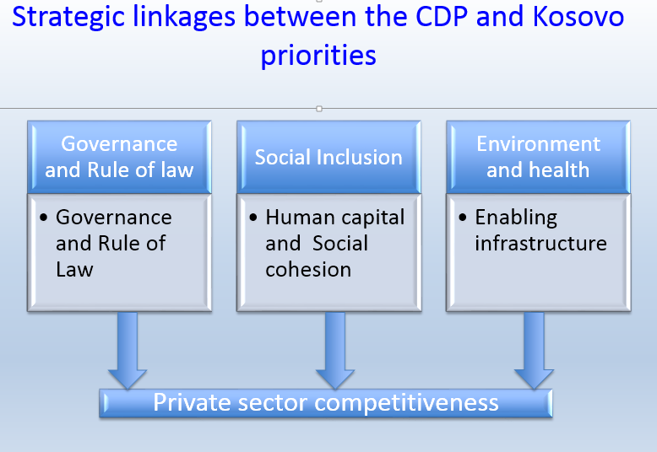
Additionally, UN agencies in Kosovo launched the “UN Common Development Plan 2016 – 2020” (UNCDP), following the simplified UNDAF guidelines, in addition to the multi-year programmes of collaboration between UN agencies and Institutions of Kosovo, lengthy consultations with key stakeholders, and including a results-oriented monitoring and evaluation framework. These joint programmes are all aligned with the National Strategic Plan 2016- 2021 of Kosovo as outlined in the scheme.
With the implementation the CDP priorities, the UN entities will support Kosovo institutions to push forward its reform process and to seek to maintain and improve its overall policy performance on the indicators, as well as its commitment to good governance more broadly. It is by the Millennium Challenge Act, that the MCC requests that the Compact-eligible countries that have not yet signed a compact are reselected each fiscal year during the time it takes to develop their Compact.
For this complex process to move forward, it requires an expansion of the space for resource mobilization with the involvement of UN agencies at all levels. Based on their comparative advantages, some of those are explained in paragraphs below.
UNDP will support with data on Corruption and Natural resource protection indicators. Previous UNDP-Kosovo Human Development Reports have highlighted the institutional need for well-defined responsibilities and accountability at the local and central level of governance. The Kosovo institutions have identified the Rule of law and governance as one of the main pillars of their five years Sustainable Development Plan. Even though evidence shows that ministers and directors are held accountable for their performance in some cases, the entire system needs strengthening to establish and consolidate democracy. UNDP in Kosovo is committed to providing support to parliament so that they have the capacity, resources, and necessary independence to be able to implement their core functions.
The Public Pulse survey, developed by UNDP and published results in March 2015, showed more than three quarters of Kosovars – 79% – believing that the largest problems that Kosovo faces today are related to their socioeconomic conditions. 52% of the respondents selected unemployment as the biggest problem, followed by 27% who selected poverty. The public dissatisfaction with Kosovo’s economic direction is even higher than dissatisfaction with its political direction: around 31% of all respondents are either dissatisfied or very dissatisfied with Kosovo’s current economic development. Corruption is ranked third on this list: 5% of Kosovars think that it is the most major problem in Kosovo.
The implementation of the Anti-Corruption Strategy and Action Plan as the main guiding documents in this area, fail to generate effective results due to lack of political support. At 54% implementation rate for the Anti-Corruption Agency (ACA) actions and measures, it is considered low performance in the EU Progress Report for Kosovo 2014.
The UNDP project funded by the Danish and Swiss governments, “Support to the Anti- Corruption Efforts in Kosovo” (SAEK) phase II, will continue working with both the supply side (the capacity building of anti-corruption institutions) and the demand side (the empowerment of the civil society and citizens). This inclusive approach will ensure that the impact of the interventions will:
1. Enable institutions to better perform their functions and mandate, and
2. Reduce corruption levels, increase public trust and decrease perception of corruption due to the increased demand of the public for transparency and accountability as the desired change.
Solid data sets produced throughout the work with anti-corruption institutions in Kosovo will show the progress. This is an in-kind contribution of UNDP to supporting "Ruling Justly" indicators for the purposes of maintaining the MCC Compact.
There is increasing evidence that anti-corruption efforts contribute to greater transparency, accountability, and integrity in decision-making processes. Due to its complexity, corruption is difficult to measure; nonetheless there is clear evidence on the correlations between corruption and economic & human development indicators. That is why all the efforts will be geared to lower scoring on corruption perceptions, i.e. Transparency International Corruption Perception Index, as this demonstrates that countries enjoy greater prosperity, opportunity, and individual liberty when this is the case.
UNICEF will continue support through monitoring progress on Education, Child Health data and immunization rate indicators based on MICS. Despite the progress made on many education indicators with net intake rate for the first grade of primary education at 92%; the adjusted net attendance rate for primary education at 98%; and the primary to lower secondary transition rate almost universal, only 76 percent of children attending first grade of primary education had attended preschool in the previous year and the adjusted net attendance ratio for upper secondary school at 82%. Primary education expenditure (grades 1-5) has increased from 1.15% of GDP in 2008 to 1.32% of GDP in 2014. The cost per pupil in 2014 was 522€ or 17.1% per pupil expenditure as percentage of per capita income. This still compares poorly with the average of neighbouring countries (24.5%) therefore still needs to pass the median of the MCC scorecard.
During 2016 UNICEF will work closely with UNESCO to provide technical assistance to the Ministry of Education Science and Technology (MEST) to produce education indicators needed for MCC reporting, which follow the international calculation methodology and are internationally comparable. During 2016 UNICEF in collaboration with UNESCO will support MEST to:
- Review the Education Indicators Framework and align with the international education indicators and methodology
- Provide technical assistance to MEST to calculate the 2015-2016 school year education indicators, for Kosovo using the international UNESCO and UIS methodology. In terms of health indicators for MCC reporting, UNICEF will continue working in close cooperation with the relevant government and international institutions to improve data collection and analysis for child health and immunization indicators in the coming years.
As reflected in the UNICEF Joint programme of collaboration with Institutions of Kosovo 2016-2020 – UNICEF plays a key role to strengthen statistical capacity and child rights monitoring through providing technical assistance and support to Institutions of Kosovo in strengthening data collection, analysis, and evidence based policy making. In this respect, UNICEF is supporting KAS, MoH, MEST in harmonization of social statistics particularly in education and health indicators, and in building capacity for quality administrative data. Furthermore, UNICEF is supporting in conducting a number of surveys to collect data – inclusive potential for conducting another round of MICS in 2018/9. UNICEF is working with the Office of Strategic Planning/Prime Minister office to further strengthen statistical capacity in light of the National Development Strategy 2016-2021 (Agenda for children).
UNICEF is also supporting the constraints analysis phase undertaken by the MCC through the Demographic Dividend analysis that highlights the needed investments for Kosovo to reap the benefit of the Demographic window of opportunity – particularly in health, education, employment, and social protection.
WHO will continue to provide technical support to Kosovo institutions to track health expenditures via their Health accounts standards and also complementary data on immunization in addition to those provided by UNICEF MICS survey. Life expectancy at birth in Kosovo is 70.2 years; ten years lower than the European Union (EU) average of 80.2 years. Total health expenditures and the health share of the government budget in Kosovo are low relative to regional and GDP per capita comparators, indicating the need to increase public spending on health. Partly as a result of limited public spending on health, out-of-pocket spending is high and contributes to impoverishment.
Additionally, the first study on Health Behaviour in School-aged Children (HBSC), a WHO and UNFPA Collaborative Study, indicates that a high percentage of youth in Kosovo (26.5%) do not use any kind of protective measure at all during intercourse. Such statistics indicate a high propensity towards risky behaviour, early pregnancy and exposure to STDs, STIs, and HIV. The same study stipulates that in general, healthy behaviour of youth in Kosovo is amongst the best compared with youth from other European countries. Nevertheless, bullying and violence in school and among youth remain one of the prominent problems, as well as the tendency to consume tobacco (4.7%), alcohol (10%), and cannabis (1.5%).
The Law on Health Insurance was approved in mid-2015 enabling the introduction and implementation of health insurance and other reforms aiming to improve the quality of primary health care services and set bases for a Health Insurance Fund. Investments in maternal and child health, in primary care facilities and hospitals, and health information systems are ongoing. This will further support the use of health sector data to inform decision-making and oversight in Kosovo.
UNFPA will provide additional quality assurance, especially related to population and health. In addition, the team will work collectively to identify venues for UN Women to provide information on gender indicators, and FAO and/or UN Habitat to fill in data gaps on land rights and access in lack of IFAD led research. All participating agencies will provide gender disaggregated data wherever possible.
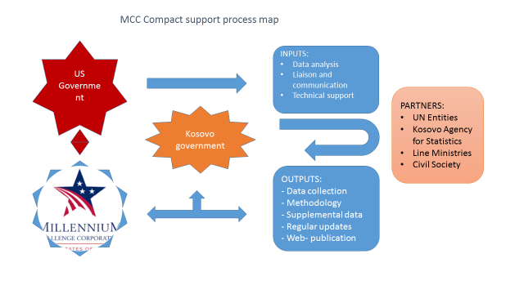
The diagram above provides a visual indication on how the UN agencies could help to convert data analysis into further immediate improvements to Kosovo’s performance on the MCC scorecard, while, at the same time, building local Kosovo capacities for data analysis and reporting over the coming years.
Management Arrangements
Funds will be administered by UNDP and implemented by the four participating UN agencies (UNDP, UNICEF, WHO, UNFPA). Resources will be utilized by the agencies in accordance with the activity-based budget shown in Annex 1. A project board consisting of the Heads of Agencies of the participating UN agencies and a representative of the MCC Office in Kosovo will provide oversight and ensure mutual accountability for the use of resources and delivery of expected results. Technical focal points from each of the agencies will contribute to the collection, analysis and monitoring of data. . The Office of the UN Development Coordinator will provide overall coordination support, including, as required, the preparation of reports to donors and other stakeholders, organization of meetings, and other administrative duties.
This concept note has prepared as a general introduction to the role that the UN agencies in Kosovo played, namely UNDP, UNICEF, and WHO has played and can continue to play as Kosovo moves along its path to MCC compact design and implementation. It serves as an initial indication as to how the UN agencies can, within current budgetary constraints, best support the MCC process during 2016. As such, the budget below shows only expected income and proposed expenditures for this period.

Annex 1: Proposed Activities and Budget by Agency (2016 only)
Agency | Proposed Activities | Budget (USD)
UNICEF | - MICS data for the score-card 2016;  - Public Expenditure on primary education for score card;  - Consultant for statistical capacity development with KAS and OSP;  - Collaboration with UNESCO on education data;  - Demographic Dividend study for Constraints Analysis; | 2,000  5,000  6,000  8,000  3,000
UNDP | - Local consultant for reporting (embedded in MCC Office)  - Coordination and communications support (including data visualization)  - Analytical support to new data relevant to the compact development | 6,000  5,000  4,000
UNFPA | - Expertize on the population demographic data | 5,000
WHO | - Consultant on the Health Accounts data | 6,000
TOTAL |  | 50,000

Annex 2: MCC Scorecard 2016
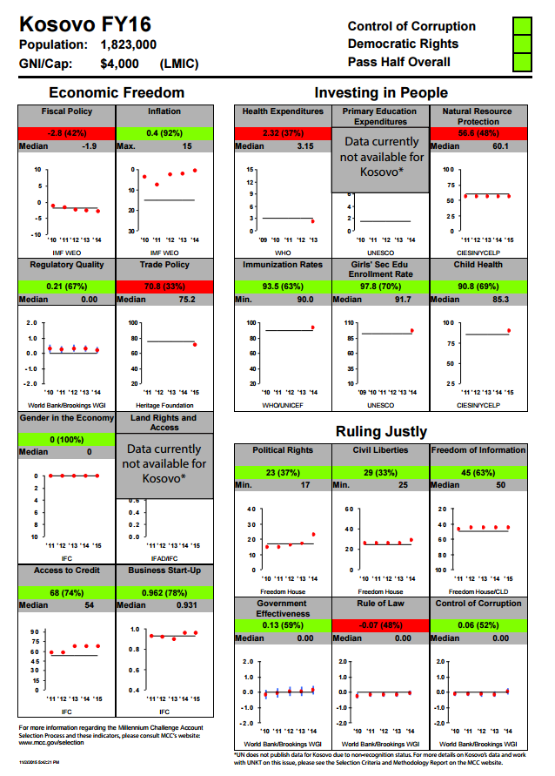

References to Kosovo shall be understood to be in the context of Security Council resolution 1244 (1999),
http://mics.unicef.org/surveys This survey in particular played a critical role in helping Kosovo to reach the minimum threshold for the MCC indicators related to “Investing in People).
Results of the Kosovo Labour Force Survey 2013; July 2014 (WB, UNDP, KAS)
Human Development Report- 2012, (UNDP Kosovo)
2013-2014 Kosovo Multiple Indicator Cluster Survey: UNICEF and Kosovo Agency of Statistics, 2015.
UN Office on Drugs and Crime (UNODC): Corruption in Kosovo: Bribery as experienced by the population 2011
UNODC/ KAS: Business, Corruption and Crime in Kosovo – the impact of bribery and other crime on private enterprise; 2013
2013-2014 Kosovo Multiple Indicator Cluster Survey: UNICEF and Kosovo Agency of Statistics, 2015.
The Public Expenditure and Investment for Primary Education in Kosovo: UNICEF; 2015

